
Thank you for choosing our product. Please read the instructions carefully before operation. Follow these instructions to ensure that the product is functioning properly. The images shown in this manual are for illustrative purposes only.
For further details, please visit our Company’s website www.zkteco.com.
SDK Document
Att Push SDK Demo Document
Date: 7/7/2020
Doc Version
English

Preface
This document intends to explain to the developer about how to add a Device to the Push Demo SDK and the newly implemented changes on Mask and Temperature Detection logs.

Prerequisites
Before proceeding with the installer build-up procedure, it is recommended to have the below mentioned files and steps covered.
Push Demo Software | PushDemo_Att | IP Address: Server IP | Port number: 6060
Hardware / Device | Attendance Device | IP Address: Server IP | Port number: 6060
File | DeviceSettingTool | Executable file

Device - Server Communication

Installation
- First, install the ”PushDemo_Att” Push Demo Software.
- And after the Demo ”PushDemo_Att” is installed, open the following http://localhost:6060/ URL on the web page and the below page will be displayed.

Connect the Attendance Device
- Configure the cloud server settings of the Attendance Device accordingly (IP Address: Server IP; Port number: 6060) and the software gets automatically updated with the active devices.
- On the software, click Device interface, to view the connected devices.
Note: If there is no device connected to the demo software, then the Device list on the Device interface will be blank as shown below.
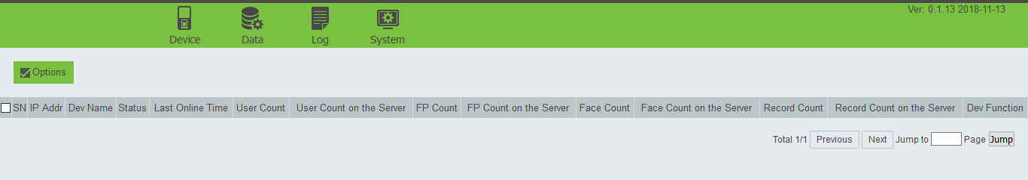

Run the Executable File
This is a validation tool which is used to verify whether the Device is sending command or not.
- When the Device is not able to connect to the Push Demo software, this validation tool verifies whether the Device is sending commands or not.
- Run the “deviceSettingTool” executable file which is provided with the installer.
- Once the deviceSettingTool interface opens, click the Search button and it will list all the device connected to the network.
Note: The listed devices indicate that the command is sent from those devices.
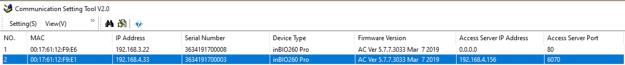
- First, select the required device from the search list.
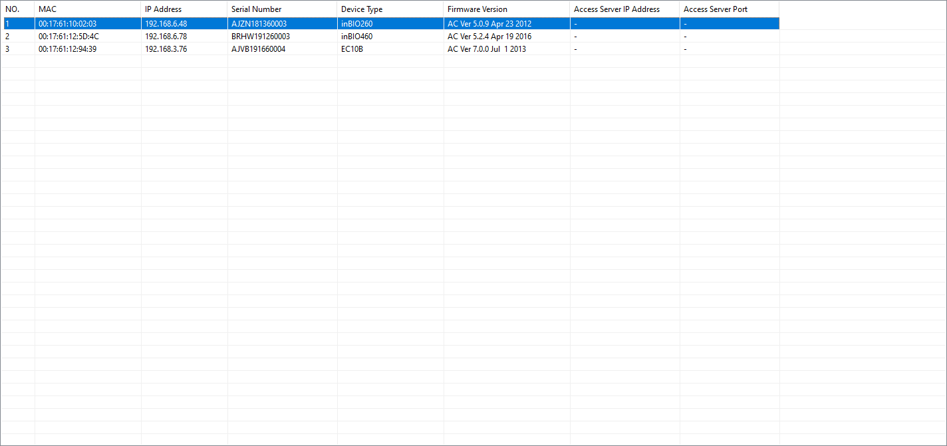
- Then on the Settings menu, click Modify from the drop-down list to edit the device details.
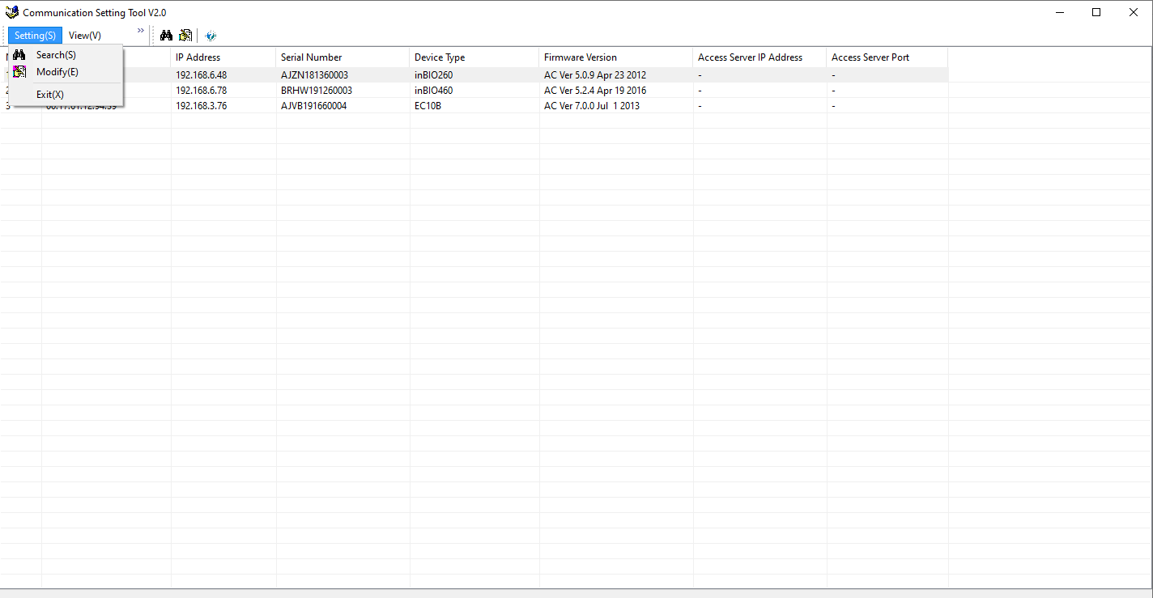
- On the Modify IP Address window, edit the required details and click OK to save and update the changes.
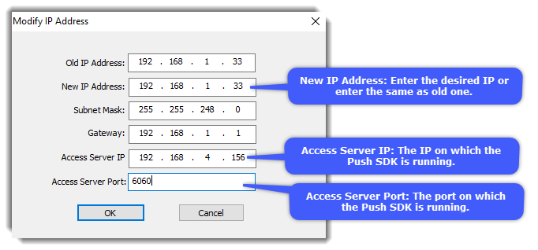

- After the required changes are updated, the device will get rebooted automatically.
- Thus, go to the Push Demo Software to view the connected Device.
- On the Device interface, the active devices will be listed, and then it can be controlled manually from the demo software.
- Now the commands for the device can be send from the Push Demo Software.
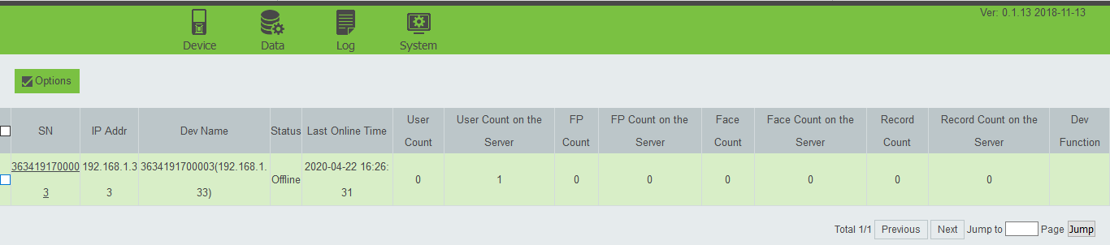

Push Attendance Details to the Device
- The example for sending command from the Push Demo Software to the Device is as below.
- Follow the below steps to Update New User Information to the Device.
- On the Device interface, click Add User to add a new user.
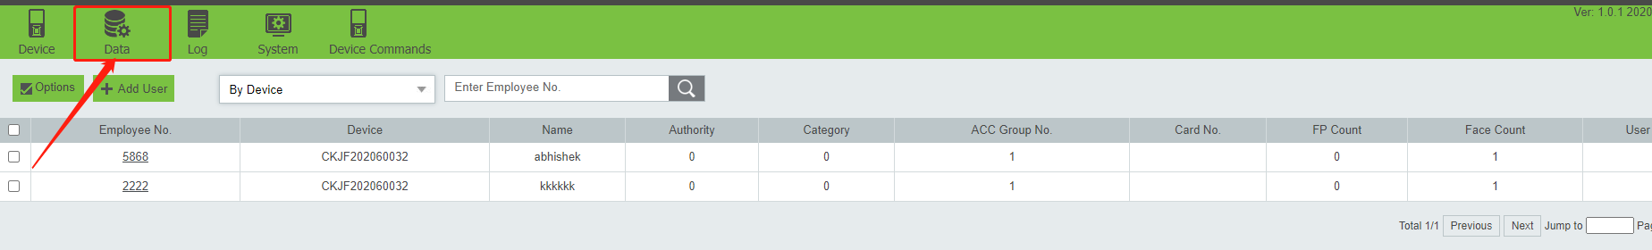
- On the Add User interface, enter all the user information and click Add to save and update the new user information to the Device.
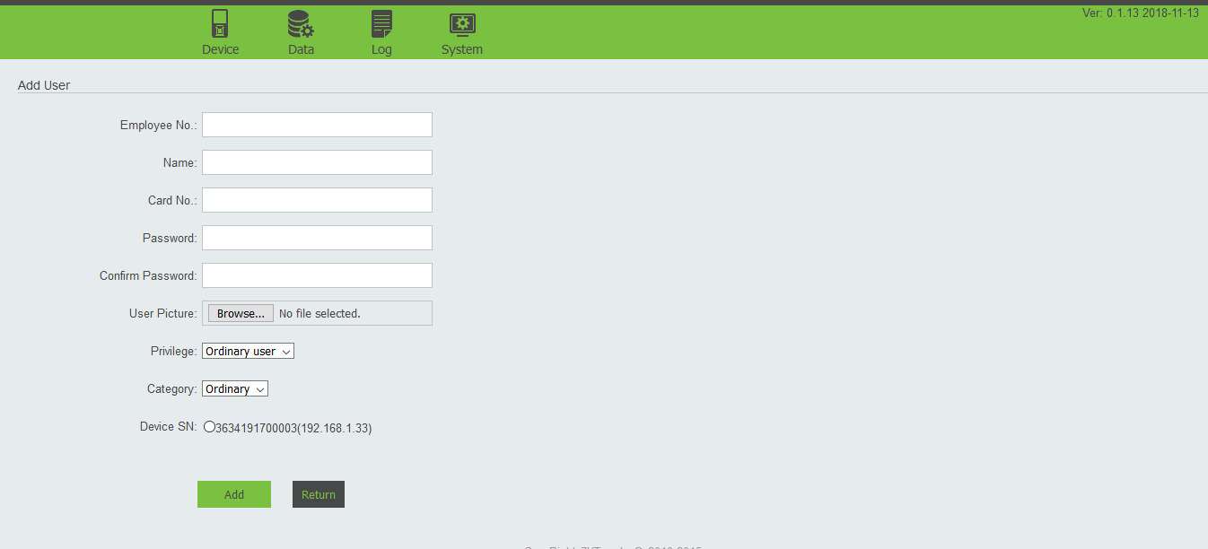
To add a person
- Once the new user is created the details will be automatically updated to the Device.

MASK and Temperature Detection: Real – Time Monitoring
- Newly Added Change (1): Mask and temperature detection shown in Real–Time Monitoring.
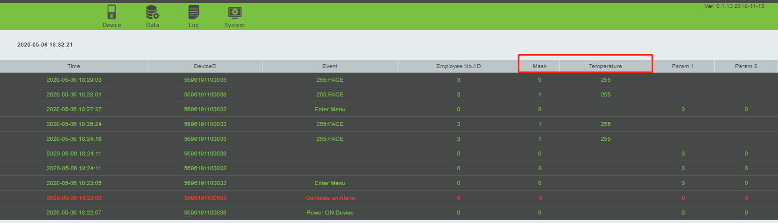
- Mask Detection Status: Displays the below status indications.
Mask Detection Status | Description
0 | Indicates Mask is not detected
1 | Indicates Mask is detected successfully
255 | Indicates Mask detection is not enabled/found

- Temperature Detection: Displays the specific reading of the detected temperature as shown in the below image.
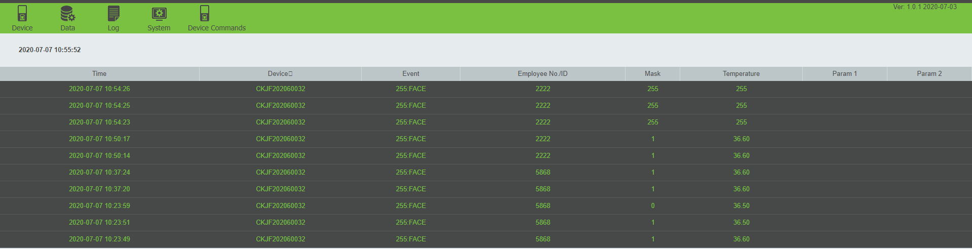
Temperature Detection Status | Description
255 | Indicates Temperature detection is not enabled/found

- Newly Added Change (2): Mask and temperature detection is configured in Push Demo Software.
- On the Device interface, Mask and temperature is enabled and is listed on the interface as shown in the below image.
